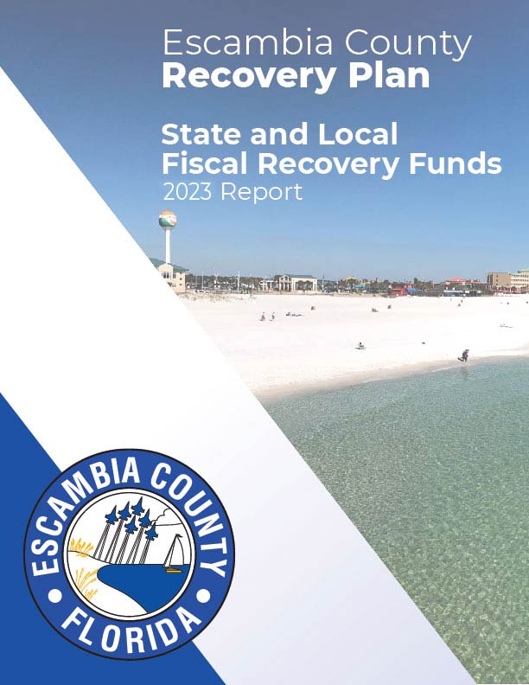
Escambia County
2023 Recovery Plan

Table of Contents

General Overview 3
Executive Summary 3
Uses of Funds 3
Promoting Equitable Outcomes 4
Community Engagement 5
Labor Practices 5
Use of Evidence 5

Project Inventory 7
Projects 7

GENERAL OVERVIEW
Executive Summary
The American Rescue Plan (ARP) includes $61.8 Million in direct local recovery assistance for Escambia County. The county’s award has been received in full as of June 2022.
Escambia County’s plan will follow the U.S Treasury Departments Interim Final ARP Rule including allocating all funds prior to Dec. 31, 2024, and completing all expenditures by Dec. 31, 2026, as required.
We recognize the impact that the COVID-19 pandemic has had on our community and are committed to making investments for economic recovery and rebuilding.
Uses of Funds
Escambia County has gathered public input and is assessing county needs to prioritize, design, and implement the American Rescue Plan funds. We want to ensure that our programs support our community and citizens and that our programs promote the below approved expenditure categories:
- Public Health (EC 1)
- Negative Economic Impacts (EC 2)
- Public Health-Negative Economic Impact: Public Sector Capacity (EC 3)
- Premium Pay (EC 4)
- Water, Sewer, and Broadband infrastructure (EC 5)
- Revenue Replacement (EC 6)

Escambia County also received $57,285,295 in CARES Act Funds that we utilized to reduce the impact of COVID-19 to our community. We utilized the funds in the following ways:
- Community Grants -
  - Families - $16,500,000
  - Businesses - $3,406,013.88
- COVID-19 Testing - $777,664.86
- Escambia Serves to Community Partners - $1,647,888.72
- Public Health and Safety - $32,203,302.84
- Government Response and Compliance - $2,480,607.92
- COVID-19 Operation and Oversight - $269,816.78

To help alleviate those most impacted by COVID-19, Escambia County has also expended funding to provide direct housing assistance for households in arrears with their rent, utilities, and mortgage to help prevent evictions and foreclosures.

- Coronavirus Relief Funds - The county provided aid to 388 households and expended $1,379,110.09 in Coronavirus Relief Funds to assist with rent, mortgage, and utility assistance.

- Emergency Rental Assistance Funds (ERA) - Escambia County received direct funding from the US Treasury to facilitate a rental and utilities assistance program. These resources are being utilized to assist vulnerable income eligible citizens in our community to mitigate the negative economic impacts associated with the pandemic. To date we have provided $1,201,873.44 (round one) and $2,748,386.29 (round two) in assistance to the community with the Treasury’s Emergency Rental Assistance Program. This assistance has allowed us to prevent homelessness for 752 households as of December 31, 2022.

- Community Development Block Grant [Coronavirus] Funds (CDBG-CV) – Neighborhood and Humans Services received funds related to alleviating the social impacts of COVID-19 for those directly impacted by the virus.

  - Emergency Mortgage Assistance Program (EMAP) has provided $160,201.23 in mortgage and/or utility assistance on behalf of homeowners within Escambia County.

  - Additionally, funds were allocated to provide $150,000.00 of assistance for legal aid services and $200,000.00 to assist with public health response to the elderly in our community, including PPE and food programs for those that are food insecure due to the pandemic.

The county is making plans related to the allocation of HOME-American Rescue Plan funds to be received through HUD to provide housing and other services directly to homeless persons. Funds will be distributed in coordination with other local jurisdictions, the local homeless Continuum of Care and local public housing agencies. County staff serve on the local Homeless Task Force which is providing local input on prioritization of funding for homeless activities.

Promoting Equitable Outcomes
Escambia County is dedicated to making a considerable effort to promote equitable outcomes during program design, planning and implementation. We continue to examine our county to identify our underserved citizens and ensure complete inclusion.

Some of our efforts to promote equitable outcomes include:
- Targeting some of our disadvantaged communities including low-income neighborhoods and special needs.
- Utilizing several outlets to get feedback from the community and to communicate our plans including a website, social media, news releases and ensuring the information is distributed at our community centers and libraries that are mostly located in the disadvantaged communities.
- The goal is to take the steps necessary to ensure Escambia County is utilizing funding that will foster a strong, inclusive, and equitable recovery to make our community stronger.
Stormwater and other clean water infrastructure projects will be prioritized in disadvantaged communities. Many stormwater projects identified in the 2015 Stormwater Advisory Team Recommendation Report are in low-income neighborhoods. The impacts of flooding and old and aging infrastructure on economically disadvantaged residents cause financial and emotional stress on these residents. The ability to repair or rebuild personal property is limited for cost burdened households in these target areas. Improvements to the infrastructure will provide long-term resiliency for at-risk households.

Community Engagement
Escambia County is taking the time to ensure we capture diverse feedback from citizens, community partners and constituents.
We have developed a web page dedicated to the American Rescue Plan to ensure transparency and communication with the public. (https://myescambia.com/american-rescue-plan)
To engage the community, Escambia County launched an ARP Survey to collect and review public input on citizen priorities for economic recovery. The results are posted on our website and attached at the back of this report.
A presentation regarding the ARP was made to the Board of County Commissioners at its public Committee of the Whole meeting on June 10, 2021. We will continue to present at future Board Meetings and Committee of the Whole workshops which are advertised and the community welcome to attend.
We are utilizing several outlets to get feedback from the community and to communicate our plans including a website, social media, news releases and ensuring the information is distributed at our community centers and libraries that are mostly located in the disadvantaged communities.
Labor Practices
Escambia County holds strong labor standards to promote effective and efficient delivery of high-quality infrastructure projects while also supporting economic recovery through strong employment opportunities for workers.
Specifically, we have implemented the use of the following:
- Davis Bacon Act
  - Department of Labor Regulations - 29 CFR Part 5 Labor Standards Provisions Applicable to Contracts Covering Federally Financed and Assisted Construction
  - Department of Labor Regulations - 29 CFR Part 3 Contracts and Subcontractors on Public Buildings or Public Work Finance in Whole or in Part by Loans or Grants from the United States
- Contract Work Hours and Safety Standards Act (40 USC 3701-3708)
These include the Equal Opportunity Clause stating that they will not discriminate against any employee or applicant for employment because of race, color, religion, sex, sexual orientation, gender identity, or national origin. It also states that in the event of noncompliance with the nondiscrimination clauses of the agreement or with any of the said rules, regulations, or order, the agreement may be canceled, terminated, or suspended in whole or in part and they may be declared ineligible for further Government contracts or federally assisted construction contracts in accordance with procedures authorized in Executive Order 11246 of September 23, 1965, and such other sanctions may be imposed, and remedies invoked.
Use of Evidence
Escambia County is evaluating their projects on an individual basis and currently does not have any projects in the categories below that require us to identify the amount of the total funds that are allocated to evidence-based interventions.
- Expenditure Category: Public Health
  - COVID-19 Mitigation & Prevention
    - 1.4 – Prevention in Congregate Settings
  - Community Violence Interventions
    - 1.11 – Community violence interventions
  - Behavioral Health
    - 1.12 – Mental Health Services
    - 1.13 – Substance Use Services
- Expenditure Category: Negative Economic Impacts
  - Assistance to Households
    - 2.1 – Food Programs
    - 2.2 – Rent, Mortgage, and Utility Aid
    - 2.3 – Cash Transfers
    - 2.4 – Internet Access Program
    - 2.6 – Health Insurance
    - 2.7 – Services for Un/Unbanked
    - 2.9 – Unemployment Benefits
    - 2.10 – Assistance to Unemployed
    - 2.11 – Child Care
    - 2.12 – Home Visiting
    - 2.13 – Services to Foster Youth
    - 2.14 – Early Learning
    - 2.15 – Affordable Housing
    - 2.16 – Services to unhoused persons
    - 2.17 – Relocation assistance
    - 2.18 – Other Housing Assistance
    - 2.19 – Community Health Workers
    - 2.20 – Lead Remediation
    - 2.25 – Academic, Social, and Emotional Services
    - 2.26 – Mental Health
  - Assistance to Small Businesses
    - 2.30 – Technical Assistance, Counseling, or Business Planning
    - 2.32 – Business Incubators and Start-Up or Expansion Assistance
    - 2.33 – Enhanced Support to Microbusinesses
  - Other
    - 2.37 – Economic Impact Assistance: Other

PERFORMANCE REPORT AND PROJECT INVENTORY
Project: Pensacola Bay Center – Lost Revenue
Project Number: 001
Funding amount: $350,000.00
Percentage Complete: 100%
Project Expenditure Category: Negative Economic Impacts/2.35 Aid to Tourism, Travel, or Hospitality
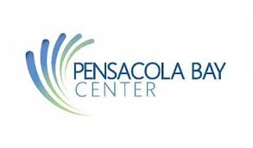
Project overview
Provided the Pensacola Bay Center with an increase to the fiscal Year 2021 Budget in the amount of $350,000 for lost revenue in 2020.
Use of Evidence
The Pensacola Bay Center is an indoor arena located in Pensacola FL. It is owned by Escambia County and operated by ASM Global. The Bay Center has capacity of 8,049 for hockey games and as much as 10,000 for non-hockey events. During the Coronavirus pandemic in 2020 the Pensacola Bay Center lost substantial revenue due to canceled games and events.
- Total of 250 events canceled or rescheduled
          - 20 Assembly
          - 5 Banquet
          - 5 Concerts
          - 1 Entertainment
          - 6 Family Events
          - 164 Meetings
          - 44 Saenger Theater
          - 5 Hockey Games
- In addition to lost revenue, they lost 12 employees and had to furlough the remaining 12 staff members and lost approximately 15,384 in staff hours.
- We have allocated the Pensacola Bay Center $350,000 in the Expenditure Category Negative Economic Impacts although their Revenue Loss was much larger:
        - 2019 Revenue = $6,023,822.57
        - 2020 Projected Revenue based on 4.10% growth = $6,270,799.30
        - 2020 Actual Revenue = $2,064,747.36
        - Lost Revenue in 2020 = $4,206,051.94

Project: Hazard Pay to Escambia County Volunteer Fire Fighters
Project Number: 002
Funding amount: $38,000
Percentage Complete: 100%
Project Expenditure Category: Premium Pay/4.1 Public Sector Employees
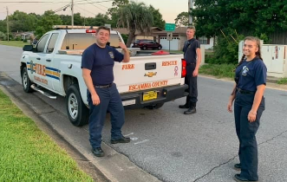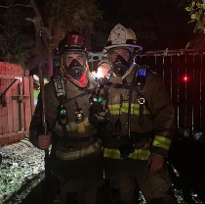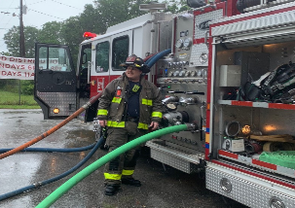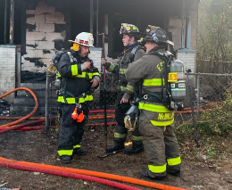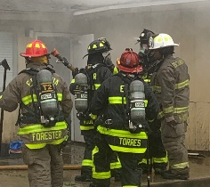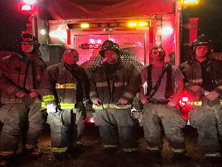
Project overview
Escambia County’s full time Fire Fighters received $1,000 in hazard pay if they met the below criteria, so we felt it was only fair for our Volunteer Firefighters who met the same criteria to also receive the same hazard pay.

Use of Evidence
To qualify for the $1,000 hazard payment, the firefighters had to meet the following criteria:
- Been a firefighter on or before March 1, 2020 through August 31, 2021.
- Meet the threshold of 25% of the first 850 calls (or total calls for the above time if station calls do not total 850 calls) for the station for the above timeframe.
- Have a minimum of 96 hours of training complete.
- Not suspended during the above period.
All reporting was gathered and reviewed, and we had 38 volunteer firefighters receive the $1,000 hazard pay for a total of $38,000.

Project: Escambia County Employees Increased Health Plan Costs 2022
Project Number: 003
Funding amount: $340,043.00
Percentage Complete: 100%
Project Expenditure Category: Revenue Replacement/6.1 Provision of Government Services
Project overview
Escambia County like many others are experiencing an increase in Medical Plan costs to their employees in 2022 due to the COVID19 Pandemic. After researching and receiving carrier quotes our board was faced with a difficult decision of keeping the budget balanced and not increasing the employee’s costs significantly. The board voted on the better option for the employees and authorized the difference in plan costs in the amount of $340,043.00 to be paid through our American Rescue Plan funds.

Use of Evidence
Escambia County currently has 1,578 active employees on one of our Medical Plans.

Escambia County budgeted $24,976,936.00 in 2021 for our share of employee medical plans with a choice to increase the budget in 2022 by either Plan A at 12.3% or Plan B at 10.9%. While both plans would not only increase the cost to the county but also to the employee the board voted to incur more of the cost to allow less of the impact to the employees. To allow us to do that they board approved the payment of the difference between Plan A and Plan B of $340,043.00 to be paid by the American Rescue Plan funds.

Project: Interlocal Agreement with the City for Roger Scott Tennis Improvement Project
Project Number: 004
Funding amount: $1,302,545.50
Percentage Complete: 75%
Project Expenditure Category: Negative Economic Impacts/2.22 Strong Healthy Communities: Neighborhood Features that Promote Health and Safety
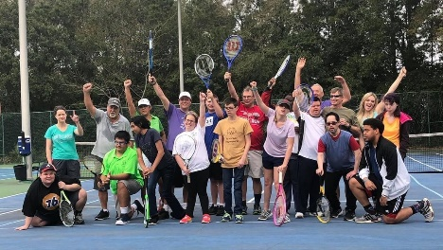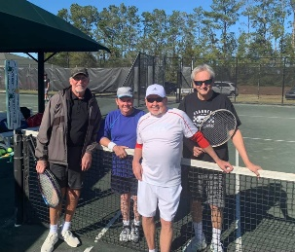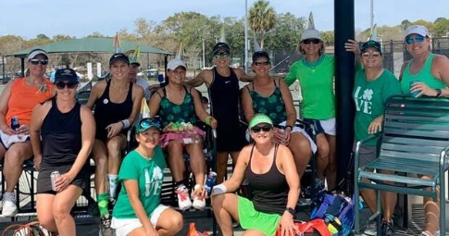

Project overview
Website - https://www.rogerscotttennis.com/
Roger Scott Tennis Center is Northwest Florida’s largest Tennis facility located in both Escambia County and the City of Pensacola. We entered an Interlocal agreement for the Roger Scott Tennis Center Improvement Project, in the amount of $1,302,545.50, with the City of Pensacola paying the remaining project costs.

- Estimated Project Milestones:
  - The project was opened for bid November 4th, 2022, and closed December 15th, 2022
  - The Notice of Intent to Award was issued January 5th, 2023
  - This project contract was signed on March 13th, 2023
  - The NTP was issued with a start date of March 20, 2023
  - The actual start date was March 20th, 2023
  - The contract end date is January 6th, 2024 (240 days including a 30 extension)

Use of Evidence
Escambia County entered an Interlocal agreement with the City of Pensacola to help cover the costs for the Roger Scott Tennis Center Improvement project. The city is the owner of the Roger Scott Tennis Center within the city limits however it is also in Escambia County and utilized by citizens outside of the city limits. The County and the City have determined that it is in the best interest of the citizens to provide for the renovations.
Roger Scott Tennis Center is not only a Tennis Center for Escambia County and the City of Pensacola it also holds several adult clinics, junior activities, leagues, tournaments, summer camps and partners with Tennis-4-Everyone. Some of these include:
- Tennis-4-Everyone, Inc. is a nonprofit organization founded in 2001 that provides free services to our local youth. They do not discriminate on the basis of race, color, religion (creed), gender, gender expression, age, national origin (ancestry), disability, marital status, sexual orientation, gender identity, or military status, in any of its activities or operations. Each summer, Tennis-4-Everyone assists with a free Racquet Round Up at several local courts including Roger Scott Tennis Center, reaching over 500 children from the local community. In the summer of 2015, Tennis-4-Everyone offered scholarships for 14 foster and guardian ad litem children to attend a week of Roger Scott Tennis Center summer camp.
- Summer camp for ages 5 to 12 years old for 5 days that includes tennis instruction, swimming, and lunches.
- Pink Ribbon Tennis Tournament supporting the Pink Ribbon charitable organization supporting the local fight against breast cancer.
- Bud Light Charity Challenge is one of Pensacola’s largest and most anticipated tournaments of the year! This even benefits Arc Gateway, an organization that provides the best possible life experiences for more than 800 children and adults with intellectual and developmental disabilities and Pensacola Sports, a private 501©3 non-profit agency that focuses on education, inspiration and participation in various team, individual, amateur and professional sports activities.
The estimated project cost is $3,554,399.75. The Roger Scott Tennis Center Improvements Project will demolish the existing 18 hard courts and replace with 12 post-tension concrete tennis courts and 6 clay tennis courts. The proposed construction will include sidewalk, parking lot, drainage, water well, electrical lighting, fencing, landscaping, pavement markings and signage. The proposed improvements will be build to meet all applicable standards and specifications from the City of Pensacola.
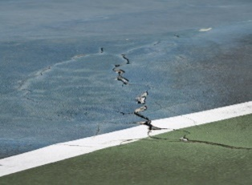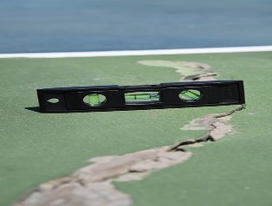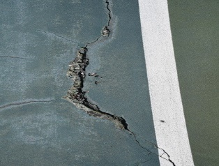
Project: Escambia County Public Safety Ambulances and Fire Trucks
Project Number: 005
Funding amount: $3,419,439.00
Percentage Complete: 50%
Project Expenditure Category: Revenue Replacement/6.1 Provision of Government Services
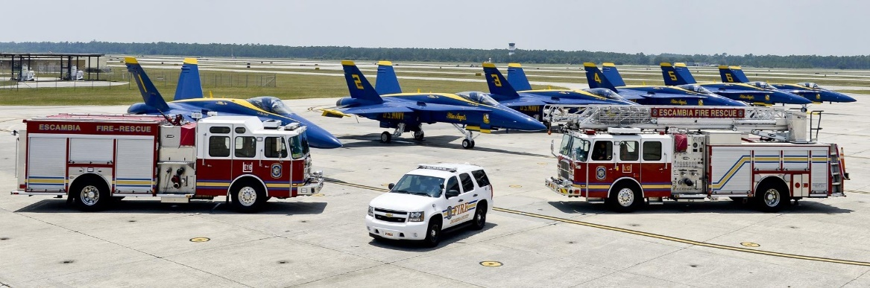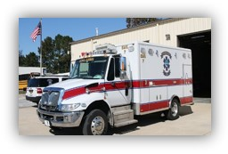

Project overview
Escambia County’s Public Safety is responsible for keeping citizens safe from emergencies and both man-made and natural disasters. Its division include:
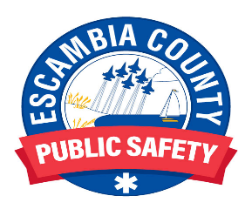
- Emergency Communications
- Emergency Management
- Emergency Medical Services
- Fire Rescue
- Pensacola Beach Lifeguards

Our Public Safety department was in dire need of new Fire Trucks and Ambulances to continue to provide the safest response to emergencies. With the assistance of ARPA funds, we were able to purchase:
- One 2022 E-One Typhoon Custom Side Mounter Pumper for $659,716
- Two 2022 Custom FC-94 Side Mount E-One Pumper Rescues at $579,861.50 each
- Eight Ford F550 Chassis with a Horton 603F Medic Conversion at $256,461 each
- Eight Stryker PowerLoad Stretcher Systems to be installed in the new Ambulances at $38,000 each

Ambulances should arrive no later than the 2nd week of November 2023.

Use of Evidence
Escambia County’s Fire Department determined the need for one 2022 E-One Typhoon Custom Side Mounter Pumper and two 2022 custom FC-94 Side Mount E-One Pumper Rescues when building a replacement plan for all apparatus. These vehicles are part of the apparatus replacement plan to bring the fleet up to an operational ready status. Items reviewed during the replacement plan include age, mileage, downtime, repair cost, safety features, parts availability, and if it would be cost effective to refurbish the apparatus. Vehicles these will be replacing range from 15 to 18 years old with over a hundred thousand miles on them which are not conductive to maintain operational fire apparatus.
Escambia County EMS is purchasing 8 new ambulances that will support the replacement of 8 of the existing units that are well beyond the ten-year, 260,000-mile replacement cycle. As new vehicles, rather than remounts, this purchase will also add much needed additional units to expand the fleet.
- Ambulance fleet consists of 37 units
- Annual call volume 2020 (Jan. 1 to Dec. 31) – 70,989
- Annual call volume 2021 (Jan. 1 to Dec. 31) – 78,106
- Population served 321,905 (2020)
- Service Area 875 square miles
Based on the overall cost of each unit, the ARPA funds will cover the cost of 5.58 of the 8 units ordered. The remaining funds to purchase these units will come from the LOST. Determinization on where to buy the vehicles from involves several factors, however, the ambulance body manufacture has not changed. ECEMS has worked with Horton Ambulance for over 25 years and has been able to facilitate orders in a very expeditious manner, compared to that of organizations that must deal directly with the manufacturer. The decision to switch to the Ford chassis is based on availability versus the international chassis, reliability, reviews of several brands (Ford, Chevy, and Dodge), and one of the most important factors, serviceability in the local area. ECEMS, like every other agency, does not have a definitive date that we will receive these units. Horton promises 120 days or less on completion of the unit, from the date the unit goes on the assembly line. This 120-day promise is when Horton receives the chassis from Ford. We expect the Ford chassis to be completed in 6 – 8 months, which means an expected total build time of 12 -18 months.
Project: Gatewood Ditch-Glyn Broc Gully Stormwater Mitigation
Project Number: 006
Funding amount: $1,000,000.00
Percentage Complete: 100%
Project Expenditure Category: Infrastructure/5.6 Clean Water: Stormwater
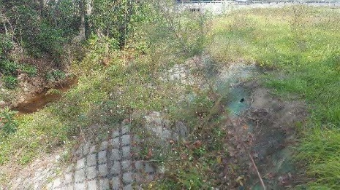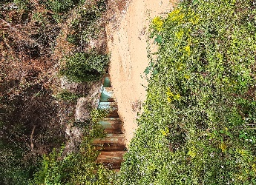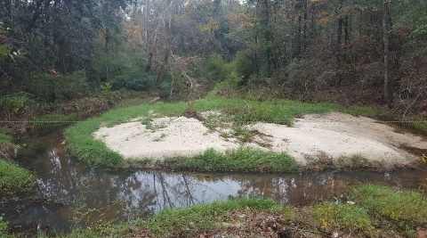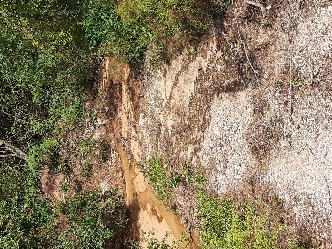
Project overview
On September 16, 2020, Hurricane Sally made landfall as a Category 2 storm in Gulf Shores, AL which caused widespread wind, storm surge, and freshwater flooding across the western Florida Panhandle. Flood and wind damage also extended well inland and into the south-central areas of the Gulf Coast. Sally was an extremely slow-moving hurricane, which prolonged and exacerbated the local impacts.
Because Escambia County is on the east side of, and directly adjacent to the landfall location, significant damage occurred to existing infrastructure. Escambia County is requesting construction services to facilitate the repair of the damage to Gatewood Ditch-Glyn Broc Gully.
A portion of the repairs will be reimbursed with Natural Resources Conservation Services (NRCS) Emergency Watershed Protection (EWP) funds and the ARAP funds in the amount of $1,000,000.00 with be used to pay for needed non-NRCS eligible additional work to better armor the outfall route for sustainability during future storm events.
- Estimated Project Milestones:
  - Design Finalized and Approved: 2/9/2021
  - Bid Package or Work Order Issued: 9/24/2021
  - Contract Accepted/Notice to Proceed: 3/01/2022
  - Scope of Work Started: 3/01/2022
  - Scope of Work Finished: 10/27/2022
  - Certificate of Completion/Project Approval: 11/14/2022
Use of Evidence
Sigma Consulting Group was placed under contract with Escambia County Engineering Department to provide a damage survey report to determine the extent and probable cause for the damage caused by Hurricane Sally. Unofficial rainfall total estimates vary from 25 to 30 inches throughout the Pensacola area. The rainfall events were unprecedented and exceeded the design rainfall events required by state, local, and federal regulatory agencies for stormwater facilities.
The Gatewood Ditech-Glyn Broc Gully drainage system is located downstream of Ellyson Park Pond on Johnson Avenue and runs parallel to Johnson Avenue into Pensacola Bay. The Gatewood Ditch- Glyn Broc Gully system is composed of three components: the main concrete ditch, the large sediment control structure, and the outfall ditch through Cypress Lakes. Hurricane Sally caused significant damage to the existing outfall system. The proposed repair work includes but is not limited to the following: demolition, removal, and replacement of the concrete ditch waterway with an expanded channel, installation of a 48” diameter stormwater conveyance pipe below the new waterway, a new outfall drop structure at the damage focal point, removal of displaced sediment, and fill-in of eroded areas damaged by the hurricane.
Project: Escambia County Universal Access
Project Number: 007
Funding amount: $1,124,963.25
Percentage Complete: 60%
Project Expenditure Category: Negative Economic Impacts/2.22 Strong Healthy Communities: Neighborhood Features that Promote Health and Safety

Project overview
Escambia County selected Project Universal Access as one of 10 initial RESTORE funded Direct Component Projects included in the 2017 Multi-Year Implementation Plan (MYIP), to address accessibility concerns on Pensacola Beach and Perdido Key.
- Estimated Project Milestones:
  - Multi-use path along Ft. Pickens Rd – Design is at 60% ($160K Budgeted)
  - ADA curb ramps for the beach – Design 100% and completed and out to bid ($240K Budgeted)
  - Via DeLuna/Ft Pickens Intersection upgrades Roads Inc. accepted this project. Construction timeline January 2024 ($240K)
  - Quietwater Beach Restroom Renovation: $2,143.09 (COMPLETED)
  - Park East restroom ramp ADA railing - $2,520.00 (COMPLETED)
  - Via DeLuna ADA crosswalks for refurbishing for compliance - $75,572.50 (COMPLETED)
  - Beach Trolly Stop - (COMPLETED)
  - Ft. Pickens Rd Cross Walks ADA - (COMPLETED)
  - Casino Beach Parking Lot ADA Striping – $258,083.00 (COMPLETED)
  - Casino Beach ADA railing repair: $4,810.00 (COMPLETED)
Use of Evidence
In September 2021, the Project produced a comprehensive Needs Assessment Report identifying potential barriers associated with County Facilities located on both barrier islands. A total of 62 separate locations were evaluated on Pensacola Beach (including multiple crosswalks, dune walkovers, and parking lots). Eight locations were evaluated on Perdido Key. Improvements were ranked by the consulting firm contracted by the County based on Title II priorities: location, use, cost, and user priority. The Needs Assessment Report also included separate cost estimates for each County facility either individually by Project site or grouped by Project type.
The total cost of all improvements was estimated to be $3,146,750. This total includes $3,089,850 for Pensacola Beach and $56,900 for Perdido Key. The following Projects on Pensacola Beach have already been completed and therefore are not included: Quietwater Beach and Restrooms (includes pavilions), Quietwater Pier, Quietwater Beach Crosswalks, and Morgan Park. Cost estimates provided in the report do not include design costs. Cost estimates were also not adjusted by the consultant to account for higher costs currently being realized on County Projects across the board. The new estimate for the total cost of all improvements, when adjusted for a 30% construction contingency and 10% design fee, is $4,499,853. This total includes $4,418,486 for Pensacola Beach and $81,367 for Perdido Key. Improvements required per site evaluated range from $1.5 million to under $1,000. The median cost of improvements per Project location is only $13,371.
Note: The American with Disabilities Act (ADA), enacted in 1990, is a Federal Civil Rights law that prohibits discrimination against disabled persons. The law is implemented by the U.S. Department of Justice (DOJ). Title II of the ADA specifically applies to state and local government agencies such as Escambia County. Title II applies to all Escambia County facilities, services, programs, activities, and events. 28 CFR Part 35, Subpart D pertains to the “program accessibility” regulations for implementing Title II ADA requirements. Subpart D requires each service, program, or activity, when viewed in its entirety, to be readily accessible to and usable by individuals with disabilities.
Project: Perdido Bay Boat Ramp
Project Number: 008
Funding amount: $2,500,000.00
Percentage Complete: 58%
Project Expenditure Category: Negative Economic Impact/2.22 Strong Healthy Communities: Neighborhood Features that Promote Health and Safety
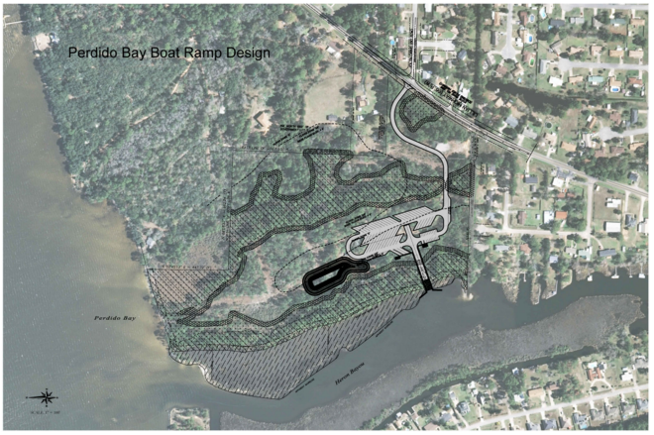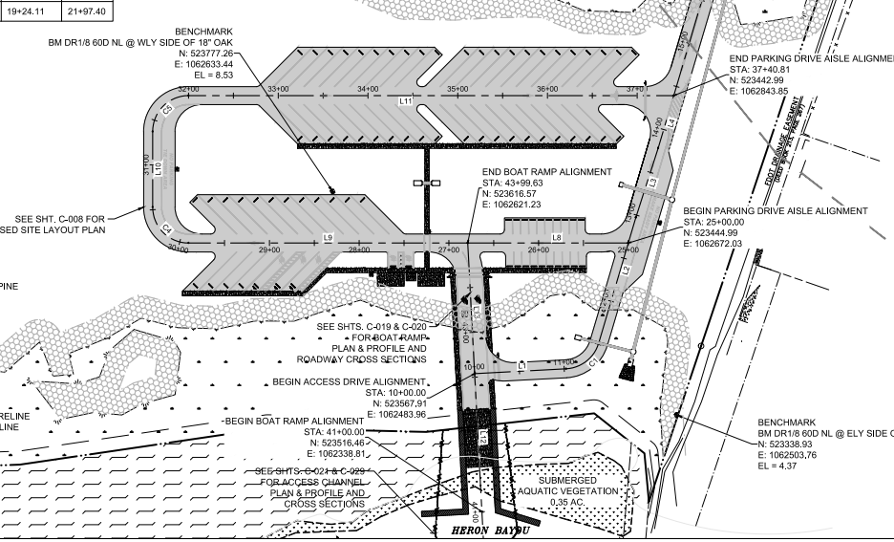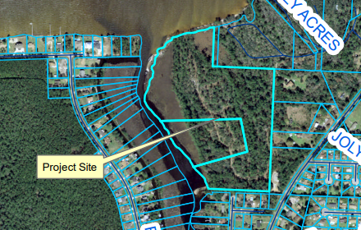
Project overview
Development of a 33.28-acre county-owned site for a public boat ramp. The development will include the construction of the boat ramp and dock, asphalt entrance drive and parking areas, concrete sidewalks, pavilion areas, primitive camping shelters and stormwater infrastructure.
  - Estimated Project Milestones:
    - Design Finalized and Approved: 8/16/2022 (Complete)
    - Bid Package or Work Order Issued: 8/24/2022 (Complete)
    - Contract Accepted: 12/8/2022
    - Notice to Proceed: 3/2/2023
    - Scope of Work Started: 3/2/2023
    - Scope of Work Finished: Anticipated 4/30/2024
    - Certificate of Completion/Project Approval: Anticipated 5/30/2024

Use of Evidence
Perdido Bay was designated as a high priority for boat ramp access by the Escambia County Marine Advisory Committee and has been a work in progress since June of 2013. We were just lacking the funds for the actual construction of the project.
- June 10th, 2013 – Board approved the purchase of three contiguous parcels of real property, located at 10836 Lillian Highway and totaling approximately 40 acres from RL REGI Florida, LLC, for a Public Boat Ramp Facility in the amount of $1,235,000.00
- March 6th, 2014 – Board approved applying for a Florida Boating Improvement Program Grant for the design, engineering, and permitting of a new Public Boat Ramp on Perdido Bay, located in the 10800 Block of Lilliam Highway.
- January 21st, 2016 – Board approved the Grant Agreement between the State of Florida Fish and Wildlife Commission (FWC), and Escambia County, FWC Agreement No. 14097, for the Perdido Bay Public Boat Launching Facility, under the Florida Boating Improvement Program in the amount of $150,000.00.
- July 7th, 2016 – Board approved and authorized the County Administrator to sign the agreement between Escambia County and Hatch Mott MacDonald Florida, LLC, per the terms and conditions of PD 15-16.043, for the Perdido Bay Boat Ramp Project, for a total of $258,360.00, for design and construction management services for the Perdido Bay Boat Ramp Project.
- The previous owner of the subject property was Heron's Forest Development Company, who granted a Conservation Easement to the Florida Department of Environmental Protection (FDEP)/United States Army Corp of Engineers (ACOE), in exchange for the ability to effect minor impact on a wetland area on the property. The Heron's Forest Development Company did not proceed with its development plans and did not perform any work on the property. For Escambia County to fully develop and make full use of the property, the County requested that the Conservation Easement be vacated. Releasing the Conservation Easement was vital to the preferred design alternative to place the ramp on the bayou versus on the open waters of Perdido Bay. The preferred design alternative offered reduced safety and maintenance concerns a ramp on the bay would create, versus a ramp on the bayou.
- October 25th, 2016 – Escambia County’s request for the release of the Conservation Easement was Accepted and approved by the ACOE and FDEP. To record the Conservation Easement and satisfy permit approval requirements, FDEP and SCOE required title insurance to be furnished as a guarantee of rights to record said easement.
- February 21st, 2019 – Board authorized staff to obtain a Title Policy and insurance on the County-owned property. Title Policy and insurance was obtained on the County-owned property in January 2021.
- October 21st, 2021- Board discussed proposed American Rescue Plan projects with the Perdido Bay Boat Ramp project being one of them.
- November 4th, 2021 – Board approved taking ownership of the Conservation Easement and it was recorded by the Clerk of Court on November 18th, 2021.
- February 10th, 2022 – The board approved funding the construction of the Pensacola Bay Boat Ramp Project with the American Rescue Act Funds and allocated an amount of $2,500,000.00.
- February 10th, 2022 – The board approved funding the construction of the Pensacola Bay Boat Ramp Project with the Florida Department of Environmental Protection Natural Resource Damage Assessment (NRDA) Grant Funds and allocated an amount of $500,000.00.
- April 21st, 2022 – The board approved funding the construction of the Pensacola Bay Boat Ramp Project with the U.S Department of Treasury Resources and Ecosystems Sustainability, Tourist Opportunities, and Revived Economies of the Gulf Coast States (RESTORE) Grant Funds and allocated an amount of $2,500,000.00.

Project: Escambia County Emergency Generators
Project Number: 009
Funding amount: $3,258,519.00
Percentage Complete: 55%
Project Expenditure Category: Public Health/ 1.14 Other Public Health Services
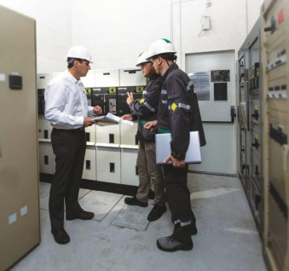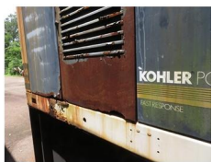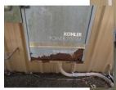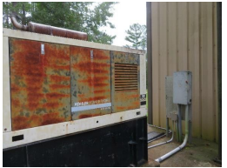
Project overview
On February 17th, 2022, we requested that the Board of County Commissioners approve the purchase of generators and automatic switchgears in the amount of $3,258,519.00 which included:
- 9 generators in critical service facilities
- 6 generators in critical support facilities
- 10 generators in fire stations
- 4 generators in drainage pond pump back-ups
- 4 portable building back-up generators
Estimated Project Milestones:
- We have received 20 of the Utility Transfer Switches, 3 Trailer Mount Generators, 6 Standby Generators installed waiting Factory Start-up, 9 generators received waiting installation, and 4 Utility Transfer Switches and Generators are on hold waiting on completed design.
- Facilities and Roads have coordinated the installation of new or enlarged concrete slabs at generator sites. Slab work to begin in May 2023,
- Facilities has developed a parts list for self-performed installation work for most new Standby units. Some units will require electrical contractor services for installation.
- Engineer design complete for the four larger installation locations. This will be part of our installation bid package. (ELM, JJC, Brownsville CC)
  - MC Blanchard Judicial Building will require a 3.2 Mega Watt generator assembly. This project is estimated to be more than $4M and has been removed from the general replacement/upgrade project list.
- We do not have delivery and serial number information on remaining un-delivered generators. We originally anticipated a 12–15-month lead time in December 2021 when they were approved.
- There was a second PO generated with a different supplier for the 3 large portable generators. These have been delivered with factory start-up complete.

Use of Evidence
Schneider Electric completed a Facilities System Assessment on critical County facilities including any generators that provided emergency back-up power to those buildings. Based on Schneider's assessment, quotes were obtained from TAW Power Systems, Inc., using the publicly bid cooperative Sourcewell Agreement # 120617-KOH for Kohler Generators, with pricing guaranteed through January 2023. Additional facilities not included in the Schneider Electric Assessment were also considered for inclusion in this Recommendation. The generator equipment has a lead time from the manufacturer of eight to 15 months for delivery. This lead time is subject to change, dependent on the order date. County staff categorized the generator needs as follows:
Critical Service Facilities - There are three Community Centers (Brownsville, MK Young, and Molino) which are used as medical needs shelters and three County facilities (Ernie Lee Magaha Building, the M.C. Blanchard Judicial Building, and the Juvenile Justice Building). Additional generators for these critical service facilities would provide power to the entire building during inclement weather or other power interruption events;
Critical Support Facilities - These facilities' current generators are old and near the end of their operational life. The six facilities are: the ECAT Administration Building, the North Camp Garage, the Pipeline Microwave, the Road OPS Garage, the Road OPS Administration Building, and the Road Prison Administration Building. Additional generators for these critical service support facilities would provide power to the entire building during inclement weather;
Fire Stations - These 10 fire stations currently have generators, but they do not provide power to the entire building. Generators for these stations (Cantonment, Century, Innerarity Point, McDavid, Myrtle Grove, Pleasant Grove, Walnut Hill, Warrington, and West Pensacola Fire Stations) would provide power to the entire building during inclement weather or other power interruption events;
Drainage/Holding Pond Pumps - These are drainage/holding ponds that have a pump but no generator. The purchase of four generators for these drainage/holding ponds (Cayden Way, Mayflower Road, East Johnson Avenue, and Littleton Street) would provide power for the drainage/holding pond pumps during inclement weather;
Portable Generators for Facilities Back-up - The purchase of four trailer-mounted portable generators would allow connection to any County facility with the flexibility of mobility. The generators can be moved to any County facility, either a stationary building or a temporary field location that might need power during inclement weather or power outage.
Installation cost of the generators is estimated based on the replacement situation. For example, some units may have a minimal installation because these are direct replacements for existing generators, while others may require engineering design for a more intensive installation build process. The estimate for installation is meant to include parts, materials, professional design, and any structural requirements to provide a complete, operational installation. The installation costs of this equipment will be bid separately after the equipment order has been placed. The installation bid will be brought to the Board for review and approval at a later date.
The total equipment (generators and automatic switchgear) cost is $3,258,519.00, for which Board approval is requested through this Recommendation.

Project: Ashton Brosnaham Athletic Park & Southwest Sports Complex
Project Number: 010
Funding amount: $1,174,280.00
Percentage Complete: 100%
Project Expenditure Category: Negative Economic Impacts/ 2.22 Strong Healthy Communities
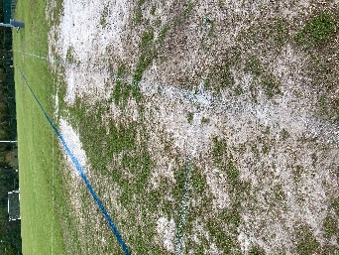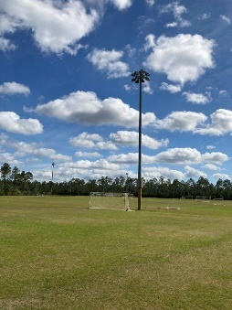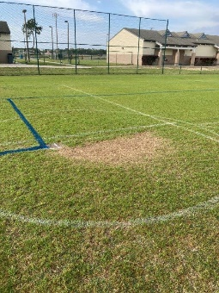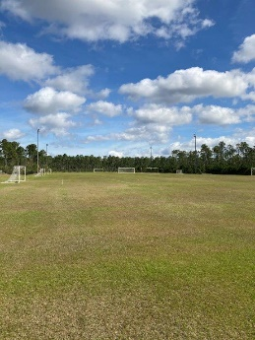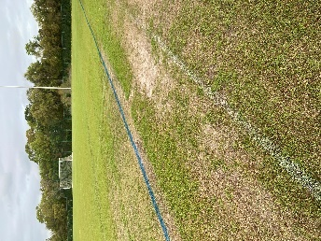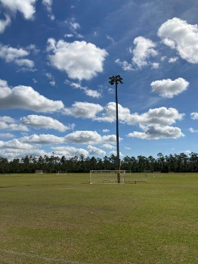
Project overview
The Ashton Brosnaham Athletic Park and the Southwest Sports Complex play host to thousands of local youth athletes and families each year. In addition to the local leagues at these facilities, these complexes also host local, regional, and national events that create an economic impact in Escambia County. To continue these events, we needed to make some upgrades and repairs to improve current conditions.
Use of Evidence
The Ashton Brosnaham Athletic Park and the Southwest Sports Complex play host to thousands of local youth athletes and families each year. In addition to the local leagues at these facilities, these complexes also host local, regional, and national events that create an economic impact.
We needed additional field lights at both complexes so our local youth would have more opportunities for practice time and game times, along with creating additional special event opportunities. The MUSCO lighting system is already in place throughout each of these complexes. The MUSCO system offers the user groups and controllers the ability to schedule lights accurately and sufficiently, along with troubleshooting when issues may arise. The purchase and installation of LED Field Lights and Poles were as follows:
- Ashton Brosnaham Athletic Park Lights - $582,000.00
- Southwest Sports Complex Lights - $310,000.00
The stadium and adjacent fields at Ashton Brosnaham Athletic Park play host to multiple special events, high school games, youth tournaments, and high-profile events that create a positive image for our area, in addition to generating a significant economic impact for Escambia County. To market and host this caliber of events, the athletic field turf must be in excellent condition.
The field turf has not been removed or replaced in over 15 years at these two fields. After review of several options for maintenance, it is in our best interest moving forward to remove the existing sod and topsoil layer, laser grade the field, and replace it with new field turf; that will also include an annual maintenance plan and service, complete with all the services needed for athletic turf to thrive in our warm environment that has continual activities throughout the year.
- Ashton Brosnaham Athletic Park Turf Replacement Total - $343,975.00
  - American Rescue Plan - $282,280.00
  - LOST IV - $61,695.00
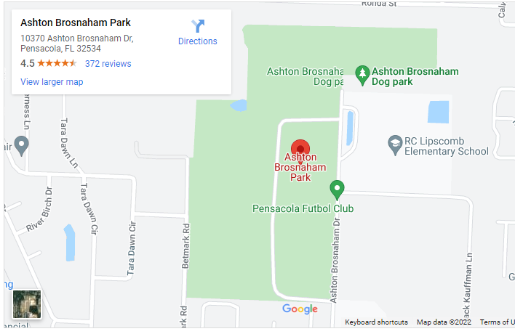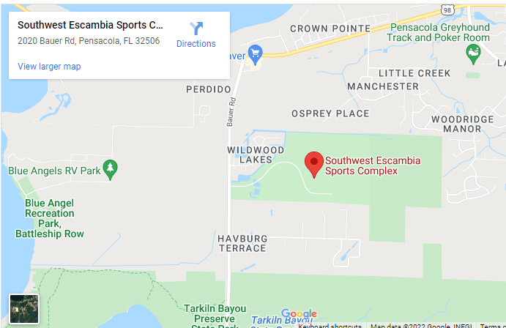

Project: Greater Rolling Hills Community Environmental Assessment
Project Number: 011
Funding amount: $71,640.00
Percentage Complete: 34%
Project Expenditure Category: Public Health/ 1.14 Other Public Health Services

Project overview
The Wedgewood, Rolling Hills, and Olive Heights communities are disproportionately impacted by
neighboring industrial uses such as borrow pits, construction & demolition pits, recycling industries,
and associated truck traffic. The most egregious impact came from the Rolling Hills C&D facility, due
to elevated levels of Hydrogen Sulfide (H2S) gas emanating from the facility into adjoining
neighborhoods. As a result of contaminated air samples collected, the Florida Department of Health
issued a Health Alert on July 22, 2014, for the surrounding areas. There continues to be concerns
regarding the operation or potential opening of new industrial uses that continue to impact these
established communities.

Funds from the Greater Rolling Hills Community Environmental Assessment Project to date has paid $24,581 for an assessment of stormwater / drainage throughout Wedgewood and surrounding neighborhoods. Escambia County was able to leverage this assessment to secure a $3,820,000 grant from the Department of Environmental Protection’s Office of Resilience and Coastal Protection, Resilient Florida Program. On August 18, 2022, the Board approved another $3,820,000 in local matching funds for the project. A total of $7,640,000 is now available to design, permit, and implement the Greater Wedgewood Area Stormwater Park and Flood Risk Mitigation Project. This project will be designed to address the community’s stormwater / drainage concerns.

The U.S. Environmental Protection Agency recently released an updated guidebook outlining development of community-based air monitoring networks leveraging new low-cost air sensor technology. This much less expensive alternative has allowed Escambia County to purchase several of the PurpleAir Flex air sensors specifically referenced by both U.S. EPA and the Florida Department of Environmental Protection without needing to expend ARPA funds. A community-based air network is being developed now. Escambia County is coordinating with FDEP to assure data collected is of the quality necessary to adequately evaluate the neighborhoods original concerns.
Escambia County used a separate funding source to contract with Dr. David Padgett to assist with a review of local codes and ordinances for environmental justice concepts to determine if sufficient language exists to compel equality regarding environmental risk and benefit for local communities. The anticipated report is expected to provide specific actionable recommendations. The remaining balance of $47,059 will be used to help implement one or more of the Padgett report recommendations and/or contract separately to analyze air quality data collected as a result of the community-based program.

Use of Evidence
In 2014, at the direction of the Board, the Natural Resource Management Department (NRM) began
monitoring air quality for H2S, and later added sites for surface water quality and groundwater to
assess potential neighborhood impacts. These datasets (2014-2021) described below have been
provided to the Florida Department of Health (FDOH) and Florida Department of Environmental
Protection (FDEP) to determine if any state standards are being violated or human health concerns.
Results from these evaluations are expected to be returned to the County later in 2022.

Outdoor Air Quality - Hydrogen Sulfide (H2S) monitoring began in July 2014. By September 2014,
the County had four fixed monitoring locations around the Rolling Hills construction and demolition
debris facility and had collected and analyzed over 330,000 individual air samples. Dramatic
decreases in H2S emanation from Rolling Hills occurred when the FDEP began the process to
properly close the landfill in 2016. This information is publicly available through the County's
website: https://myescambia.com/our-services/natural-resources-management/air-qualitymonitoring.

While community-wide particulate matter (PM2.5) real-time monitoring is not currently performed like
it is for H2S, PM2.5 monitoring is required for all County-issued recycling permits to evaluate the risk
of fugitive dust. The two recycling facilities, Sunbelt Crushing, LLC and Eager Beaver Professional
Tree Care, LLC in the area is monitored randomly, a minimum of once per quarter. Both companies
operate dust suppression systems to minimize off-site impacts. These two facilities are currently in
compliance with their permit conditions. This information is publicly available through the County's
website: https://myescambia.com/our-services/natural-resources-management/particulatemonitoring.

Surface Water Quality - Surface water quality monitoring began monthly in March 2019, with seven
stations beginning in the two upper branches of Bayou Marcus Creek, and following downstream to
the Crescent Lake Dam. The purpose of the monitoring stations is to determine if solid waste or
recycling facilities in the area are causing measurable impacts on downstream resources. These
monthly monitoring events evaluate over 80 laboratory and field parameters including heavy metals,
nutrients, volatiles, and residuals. These parameters were based primarily on state permit
requirements for solid waste facilities. Of note, there are detections of impacts downstream of the
Rolling Hills facility that are consistent with a construction and demolition debris facility, an area of
low dissolved oxygen without the causative pollutant responsible being determined, and a fish
consumption advisory for Crescent Lake.

Groundwater Monitoring - Groundwater monitoring began in January 2020, to include wells on
County property along the northern boundary of the Rolling Hills facility. Wells are monitored monthly
for over 50 laboratory and field parameters including heavy metals, nutrients, volatiles, and residuals.

The Environmental Justice Ad-Hoc Committee was established in December 2020, with a mission to assist Escambia County’s aspiration to achieve environmental justice through its governments,
communities, citizens, industries, and agencies, by partnering to promote healthy communities, along
with a clean and safe ecosystem. Priorities of this committee include:
- Elimination of off-site impacts from area industry such as noise, vibration, fugitive dust, odor,
and storm water (possible flooding) - funding for supplemental PM2.5 monitoring needed
- Flooding - funding needed to update basin study
- Septic to Sewer Conversion – coordination with ECUA to encourage prioritization for
underserved areas
- Sidewalks and Streetlights – Projects ongoing to address

Recommendations:
- Hydrogen Sulfide - recommend reducing monitoring stations to the single station at the Marie
Young Community Center and continuing to provide real-time results on the County website.
- Particulate Matter - recommend adding three new fixed PM2.5 stations at the Marie Young
Community Center, George Stone Technical College, a third location to be determined, and
establishing a three-year term FTE at the Environmental Analyst level to implement the
additional monitoring and manage the program. Data will be compared against reference
stations located in Ellyson Industrial Park and Naval Air Station Pensacola. NRM staff will
coordinate results with the FDOH and FDEP to determine if action is needed. NRM has
applied for a grant to offset the expense of the equipment and personnel.
- Surface and Groundwater Monitoring - recommend continuing the existing level of monitoring
for the next 36 months.
- Environmental Justice Program - There are areas within the County where existing zoning
allows industrial uses near residential neighborhoods, resulting in incompatible uses
negatively impacting underserved communities. To minimize additional harm to these
communities, NRM staff recommends the Board consider authorizing a Contract with Dr.
David Padgett, Tennessee State University, to perform a review of existing Codes and
Ordinances and provide Recommendations to enhance Environmental Justice concepts in our
regulations (cost $12,000). These regulations would require a minimum setback between
certain industries and existing communities and require an environmental justice review of
other potentially impactful industries not covered by setbacks.
- Allocate up to $100,000 to update basin studies and begin design to address local flooding
concerns specifically around: Kyle Dr., Capital Blvd., Twiggs Ln., Saxton St., Ludlow St.,
Cutter St., Rolling Hills Rd., Kemp Rd., Gulley Ln., Field Ln., Angel Ave., Wingfoot Way.
- Authorize staff to begin due diligence to possibly acquire the Rolling Hills construction and
demolition debris facility for potential future recreational amenities, and to assure that it does
not reopen in the future.

Project: NORTH Escambia County Broadband Project
Project Number: 012
Funding amount: $6,300,000
Percentage Complete: 85%
Project Expenditure Category: Infrastructure/ 5.20 Broadband: Other projects

Project overview
The future of our communities lies in their ability to participate in the digital economy. Fast, economical, and always on broadband will support the ability of communities across the globe to keep government functioning efficiently, support the connectivity needed for a Smart County and allow citizens to access online education, telehealth, buy and sell goods online, utilize online banking, and access government services. Simply put – every year our lives increasingly move online and depend more and more on broadband access and connectivity. Communities that remain underserved or unserved by world class fiber and wireless connections will fall behind. Escambia County’s leadership recognizes that its current broadband connectivity is lacking the infrastructure and access needed to support a thriving community and citizenry. Leadership has a goal of ensuring all their citizens can access and connect to affordable state of the art broadband.

North end of the County
  - Contract was awarded to Escambia River Electric Cooperative (EREC) in partnership with Conexon Connect.
  - Bid Amount from the County was $6.3 million with the total cost estimated at $24 million.
  - Estimated Project Milestones
    - Fiber Analysis/Design – Complete
    - Make Ready Engineering – Complete
    - Fiber Construction – In progress, target complete in Dec 2023
    - Fiber Splicing – In progress, target complete in Jan 2024
    - Service drop and NID Installation – 35 Weeks
- Total Miles of Fiber Deployed (Planned): 70 miles planned for the ring to cover 28 community anchor institutions funded by the grant, 589 miles planned for the FTTH locations not funded by the grant.
- Funded Locations Served
  - Total Number of Funded Locations Served (Planned): 28 community anchor institutions funded by the grant. 3,721 locations represent the remainder of the FTTH locations not funded by the grant within EREC’s territory.
  - Total Number of Funded Locations Served Receiving 25/3 Mbps or below (Pre-Investment) - (Planned): 2,857
  - Total Number of Funded Locations Served Receiving between 25/3 Mbps and 100/20 Mbps (Pre-Investment) - (Planned): 864
  - Total Number of Receiving Minimum 100/100 Mbps (Post – SLFRF Investment) - (Planned): 3,721
  - Total Number Receiving Minimum 100/20 Mbps and scalable to 100/100 Mbps (Post – SLFRF Investment) - (Planned): 0
- Total Number of Funded Locations Served by Type
  - Residential (Planned): 3,399
  - Total Housing Units (Planned): 3,399
  - Business (Planned): 321
  - Community Anchor Institution (Planned): 28

Use of Evidence
In late October 2020, Escambia County issued an RFP for a broadband feasibility study. Magellan Advisors, alongside other firms, provided a detailed proposal and response to the RFP. Escambia County awarded the Broadband Feasibility Study to Magellan Advisors. The study’s goals were to understand any gaps in infrastructure and access to the community members, anchors, and businesses in Escambia, and define solutions to solve those gaps. Magellan deployed considerable resources and was able to provide a complete a detailed Feasibility Study before December 30, 2020. For several years residents of Escambia County have complained about both the access and cost for quality broadband, and some areas, mainly in the north part of the county, have little or no broadband connectivity.

As part of the of the Feasibility Study, a detailed and comprehensive resident survey was conducted and confirmed that much of Escambia County was truly underserved. The Feasibility Study outlined the state of broadband in Escambia County, recommendations, and an informal plan to propel the County forward in helping to solve the broadband unserved and underserved problems within the county. Major findings from the Broadband Feasibility Study:
• The study demonstrates demand for high-speed internet.
• The study demonstrates and confirms areas with under and unserved residents.
• The County desires to serve the needs of these under and unserved residents.
• The study identified about 3,000 under and unserved residents.
• The County desires to both retain and expand business and economic development opportunities.
• The County desires to reduce operating cost and enhance services for its residents and businesses.

Based on the results of the Feasibility Study it became clear that the County must be a driving force to solve the broadband connectivity issues across the entire county. Magellan determined the best and most effective ways to achieve the broadband goals is for the County to build, own and operate its own community fiber-optic broadband network, Escambia Fiber Network (EFN). Based on this conclusion, several benefits of the network have been highlighted in the Feasibility Study and the results/recommendations were presented to the County Commission. Besides a major annual savings on County connectivity estimated at approximately $676,000 in taxpayer savings the following are also identified.

The network will make available 1 Gigabit and 150 Megabit internet service for more than 3,000 underserved residents and businesses. For fiber customers this would be a symmetrical service which has become a necessity in today’s cloud-based application environment, the fiber will also be hardened and extremely reliable as a complete underground fiber network. The County-owned network will also be a fully redundant system which does not exist today and a requirement for many businesses and all of the County’s operated services. The network will have positive impacts for economic development, students and education, and healthcare - especially related to the on-going pandemic. The network also ensures the County will have control of its broadband future and self-determination in supporting its residents. The below is the conceptual network overview of the planned and designed hybrid fiber-wireless network.
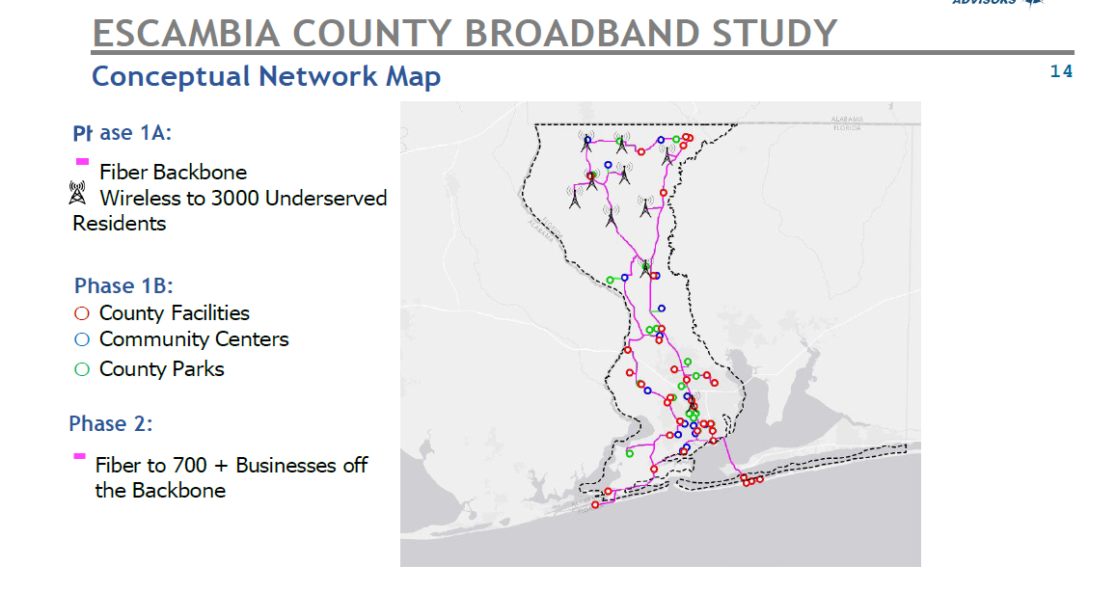
The final feasibility study and presentation to the County Commissioners took place January 14, 2021. At that meeting a Power Point presentation with full details and a lengthy question and answer session took place. The specifics of the plan are as follows. The fiber-wireless network would be an estimated 193.2 miles of underground 288 count high-capacity fiber-optic network. The network would connect 9 towers for the wireless CBRS deployment providing broadband services for more than 3,000 underserved residents and connect 96 county identified facilities. The network would also pass and estimated 700 businesses within 500 feet of each side of the backbone. The network at that time had an estimated cost of $22.8 million plus any desired new data center construction cost and was to be paid mostly from new County debt. However, shortly afterwards the County was awarded federal grants commonly referred to as ARPA funds thus requiring no debt or debt services or a “payback model”. During the commission presentation Magellan recommended certain steps to be implemented as preparations for the actual construction and deployment of the network. These steps include design engineering, grant funding overviews and opportunities and a well-defined business plan to leverage the network assets. These tasks were estimated to cost about $645,000 and was approved by the commission to be funded by left over federal CARES grant monies. Upon the approval, Escambia County issued an RFP for the services and in late summer 2021 Magellan was awarded the contract after being declared the winning bidder through the County’s comprehensive procurement process.

On December 30, 2021, the full design-engineering was completed based on updated information and requests from the County during the design-engineering process the completed design now includes 127 county facilities, an increase of 30 sites from the feasibility study and cost estimates. To complete the finished design and to encompass the additional 30 county facilities an additional 34.8 miles was added to the network construction cost resulting in an additional $5.6 million in extra construction costs. The cost of conduit and steel pipe and plating has more than doubled in cost since the feasibility study was concluded which is much greater than the 15% contingency built into the original cost estimates. High count fiber, cabinets and hardware has increased by about 40% over the last 12 months, labor has increased by about 15-20%. This equates to roughly a 40-50% increase in materials and labor cost over the last 12 months.

Cost changes from the feasibility study estimates and based on actual low-level design-engineering with a 12-month difference in material costs also reflects milage increase to connect new facilities and cost increase:

Feasibility Study |  | Final Design-Engineering  (12 months later)
Construction | $19.82M/195.2 miles | $29.2M/230 miles
Facilities | 97 | 127
Electronics and Wireless | $3.0M | $3.0M
New Data Center Building | $400K | $400K
Total | $23.2M | $32.6M

Project: S Chemstrand Rd Drainage and Sidewalk Improvement Project
Project Number: 013
Funding amount: $3,400,000.00
Percentage Complete: 0%
Project Expenditure Category: Infrastructure/ 5.6 Clean Water: Stormwater
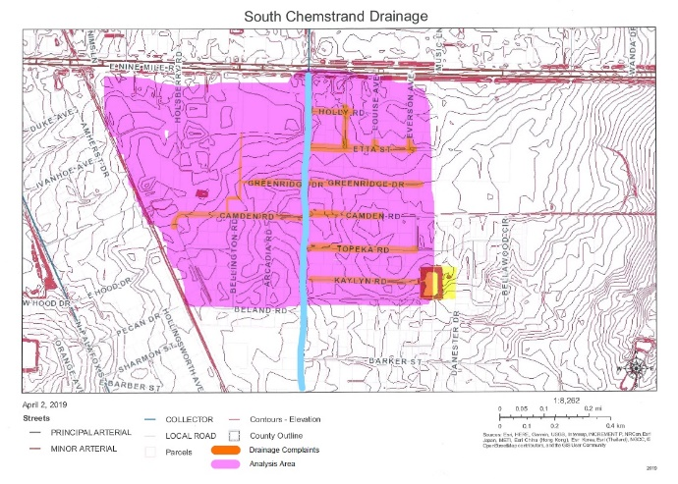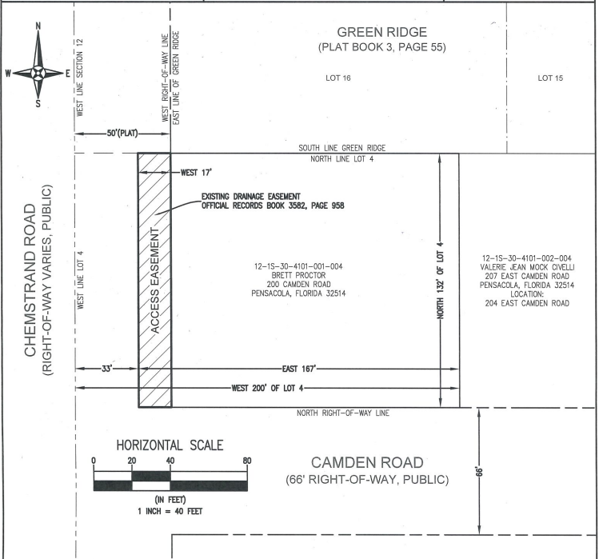

Project overview
The South Chemstrand Road Drainage and Sidewalk Improvement Project will create positive drainage and a safe pedestrian pathway from Nine Mile Road to Johnson Avenue, along the southern segment of Chemstrand Road. This project includes the design and construction of sidewalks and drainage improvements. The sidewalk improvements will connect to existing commercial facilities on the Nine Mile Road corridor and to sidewalks along Johnson Avenue that serve Ensley Elementary School. The original estimated construction cost was based on sidewalk installation and minor pavement rehabilitation. With the addition of drainage improvements and infrastructure, the estimated cost for construction increased by an estimated amount of $3,400,000.
- Estimated Project Milestones:
  - Design Finalized and Approved: 1/25/2023
  - Bid Package or Work Order Issued: 3/23/2023
  - Contract Accepted/Notice to Proceed: 11/06/2023
  - Scope of Work Started: 11/06/2023
  - Scope of Work Finished: 4/04/2025
  - Certificate of Completion/Project Approval: 5/04/2025

Use of Evidence
Meeting in regular session on July 19, 2018, the Board approved and authorized the County Administrator to sign the Agreement between Escambia County and Rebol-Battle & Associates (RBA), LLC, per the terms and conditions of PD 17-18.042, South Chemstrand Road Sidewalks Design, for a lump sum amount of $98,842.84.

When the design of this project began, there were no documented drainage complaints. In January 2019, flooding questionnaires were sent to area residents. The residents responded with reports of neighborhood flooding. In March 2019, at a public meeting, several residents expressed their concerns, and it was determined that the drainage issues needed to be addressed. At their regularly scheduled meeting on July 18, 2019, the Board approved and authorized an $81,331.82 Change Order for the additional design services required to ensure that proper drainage would be installed within the South Chemstrand Road area; the revised Design Contract with RBA, LLC, is $180,174.66. These additional funds allowed the design engineer to gather off-site survey information, complete a drainage analysis of the area, and design a stormwater system to meet the current drainage demands.

Total construction funding allocated to date is $1,300,000, with a current balance of $1,100,000. The current construction estimate is $4,500,000, creating a deficit of $3,400,000 for this project, which is the request for ARPA funds.

Project: Ferry Pass Community Center
Project Number: 014
Funding amount: $671,250.00
Percentage Complete: 20%
Project Expenditure Category: Negative Economic Impacts/2.22 Strong Healthy Communities
(PHOTOS)
Project overview
ARPA funds were utilized to purchase of Property from UWF to create a Community Center in March 2023. The Ferry Pass Community Center project is located at 8800 North 9th Avenue in District 4. An existing 8,000 SF +/- building on the site will be renovated into the proposed Community Center by the Escambia County Facilities Management Department. The Escambia County Construction Management Division will manage the site improvements around the existing building, including but not limited to, a new parking lot, stormwater attenuation and detention, landscaping, and lighting.
- Estimated Project Milestones:
  - Facility Renovations – estimated at $260,000 (Working on Funding Source.)
  - Engineering Site Updates – estimated at $669,000 to $769,000 (Working on Funding Source.)
    - Design - $69,000 (Funding Source LOST IV)
    - Construction - $600,000 to $700,000 (Funding Source Unidentified at this time)
  - Parks and Recreation – Adding playground and outdoor workout equipment – total cost was $70,426.23 paid for by LOST 4 Parks Allocation. Estimated to arrive in January for installation.

Use of Evidence
This project scope is limited to the approximately 8,000 square foot community multiuse building and property perimeter. The building was constructed as a religious facility in in 1984 with renovations in 2018 and 2019 to convert the religious ceremony and support spaces to large meeting rooms and offices. Escambia County purchased the property in 2023 with plans to convert to a multiuse community center. The current interior renovation plan contains no structural changes to the building. A few interior partition walls will be removed to allow for spatial improvements. Building systems of electrical, plumbing will undergo some minor upgrades while a complete HVAC replacement is planned. Interior building finishes will be refreshed or upgraded including removal of spray-on ceiling materials, restoration of ceiling, wall painting, flooring replacement, and warming kitchen fit-out. Exterior improvements of the building include lighting upgrades, cleaning, and new perimeter fencing. The IT Department will be installing a new network node on a robust fiber optic connection with wireless connectivity inside the building and VOIP telephone service.

Project: Olive Rd Street Improvement Project
Project Number: 015
Funding amount: $4,450,000.00
Percentage Complete: 0%
Project Expenditure Category: Infrastructure/5.6 Clean Water: Stormwater
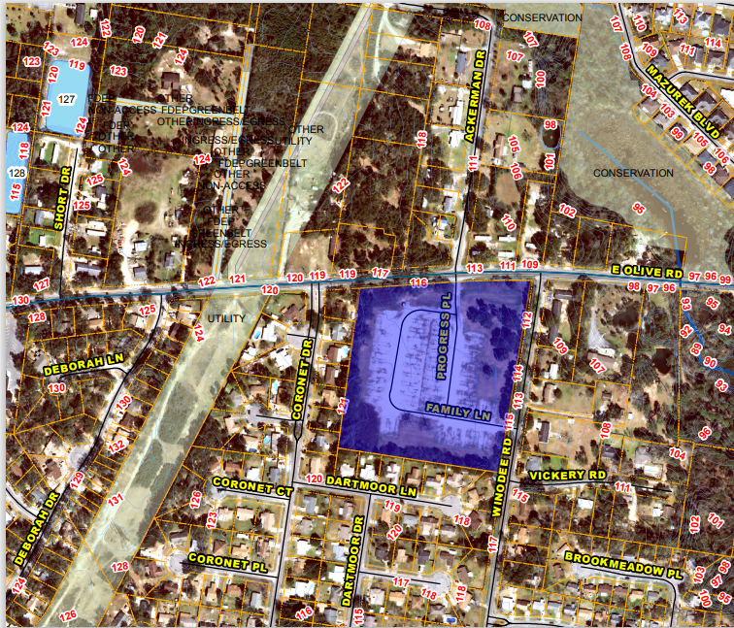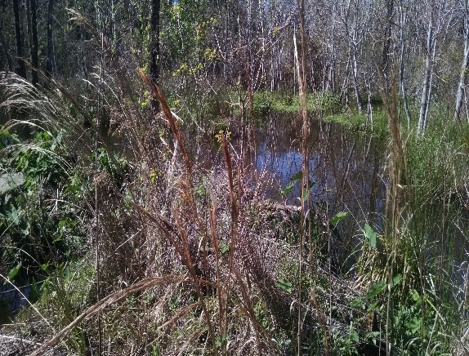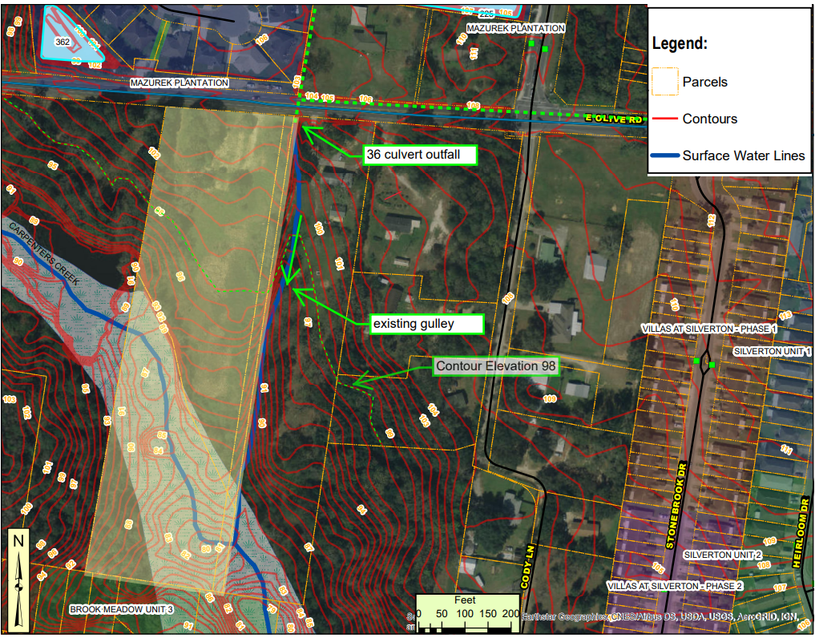
Project overview
The western section of Olive Road (Palafox Street to N. Davis Highway) has been under review for upgrades dating back almost 30 years. This project is to complete some of the remaining Olive Road Street Improvement Projects.
- Estimated Project Milestones:
  - Design Finalized and Approved: 2/25/2024
  - Bid Package or Work Order Issued: 4/23/2024
  - Contract Accepted/Notice to Proceed: 7/18/2024
  - Scope of Work Started: 9/19/2024
  - Scope of Work Finished: 4/30/2026
  - Certificate of Completion/Project Approval: 5/30/2026

Use of Evidence
The western section of Olive Road (Palafox Street to N. Davis Highway) has been under review for upgrades dating back almost 30 years. In the early 1990's, the Florida Department of Transportation (FDOT) owned the road and looked at expanding Olive Road to four lanes and extending it to the west to connect with US Highway 29. However, the project never got past the 100% design phase, and the additional right-of-way required was never purchased. FDOT added paved shoulders, side drainage, and resurfacing improvements in 2005. In 2009, the Florida-Alabama Transportation Planning Organization (TPO), with the support of Escambia County, conducted a corridor study of Olive Road West and recommended adding curbs and gutters and widening to a three-lane typical section with a two-way left-turn (TWLT) lane. Separate sidewalks and bike paths were also recommended. In 2011, FDOT swapped Olive Road for Airport Boulevard and in that exchange, FDOT provided Resurfacing, Restoration, and Rehabilitation (RRR) design plans, prepared by FDOT, to Escambia County, along with funds to allow Escambia County to resurface the roadway to bring it up to a better condition. In 2013, Escambia County milled and resurfaced the road and replaced the cross drain at Carpenters Creek. More recently, Escambia County widened Olive Road to the east of N. Davis Highway by adding a TWLT lane, four bike lanes, and 6' sidewalks directly adjacent to the curb along both sides of the road. The goal of this project is to reduce/eliminate crashes by constructing necessary drainage/stormwater improvements and by improving mobility for people by enhancing vehicular flow and building dedicated bike and pedestrian lanes.

The current corridor has industrial zoning on the west end, with residential/mixed-use in the middle, and commercial zoning along the east end of the project. From Palafox Street to Cody Lane, the traffic has stayed essentially the same or slightly reduced over the last 15 years, from 13,200 Annual Average Daily Traffic (AADT) in 2005 to 11,400 in 2020. From Cody Lane to N. Davis Highway, traffic has increased from 17,600 AADT in 2005 to 21,000 in 2020. Escambia County Area Transit Authority (ECAT) operates two bus routes (45 and 51), with six existing stops, along this corridor.

Meeting in regular session on August 19, 2021, the BCC approved and authorized the County Administrator to sign Contract PD 20-21.052, Olive Road (West) Street Improvement, with Moffatt & Nichol Inc., for Design Services, for the lump sum of $787,538.72.
Total construction funding allocated to date is $3,350,000. The current construction estimate is $7,800,000, creating a deficit of $4,450,000 for this project, which is being requested from ARPA.

Project: Brownsville Masonic Lodge Library Project
Project Number: 016
Funding amount: $3,100,000.00
Percentage Complete: 15%
Project Expenditure Category: Negative Economic Impacts/2.22 Strong Healthy Communities
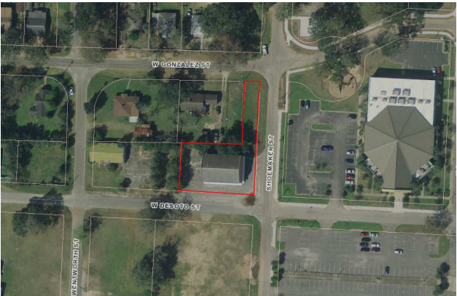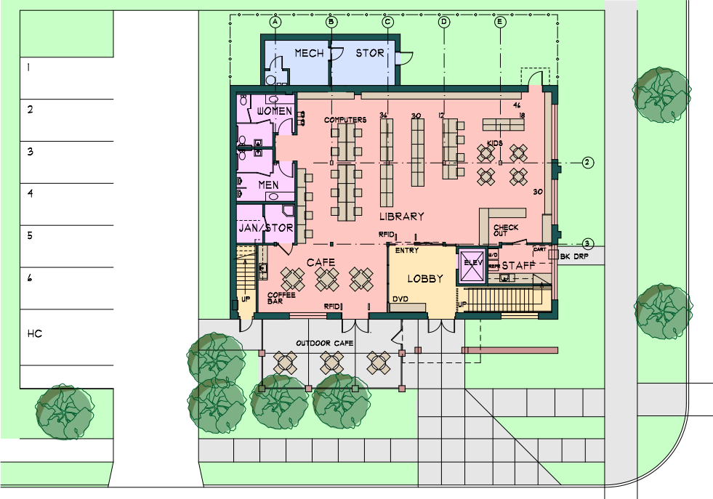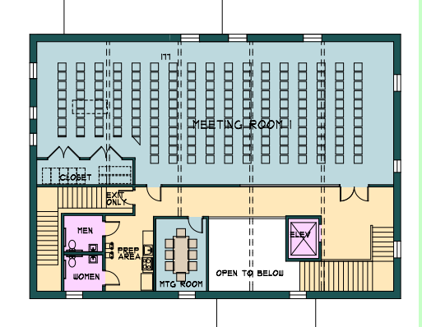

Project overview
The Brownsville Masonic Lodge located at 3300 West Desoto Street Pensacola; FL 32505 is scheduled to be converted into a library with a meeting center. The project will include the modification to the two-story 7,810 square foot facility.
- Estimated Project Milestones:
- AE Selection - Selected and Board Approved August 22, 2022
- Construction Documents Complete – April 30, 2023
- Building Inspections Review – May 17, 2023
- Bids Opened – Original bid June 15, 2023. Re-bid required due to only one vendor submittal. New bid opening 10-24-23
- Construction Notice to Proceed – November 7, 2023
- Begin Construction – January 31, 2024
- Construction Completed – January 31, 2025

Use of Evidence
The proposed development is located on an abandoned parcel addressed as 3300 West Desoto Street in Escambia County (County) and is further identified by property reference number 33-2S-30-3300-006-257. The ±0.37- acre parcel is a corner lot that contains a vacant brick building, sidewalks, asphalt pavement for vehicular access and parking and an open green space along Shoemaker Street.

Escambia County is requesting the Consultant serve as the Engineer of Record (EOR) for the proposed development which we understand to include a renovation of the existing building, new parking rows to include islands, driveway connection(s) to the adjacent public rights-of-way, sidewalks for internal access and circulation, a dumpster pad with enclosure, and all supporting utility and stormwater management infrastructure.

Project: Massachusetts Avenue Drainage and Sidewalk Improvement Project
Project Number: 017
Funding amount: $3,451,741.00
Percentage Complete: 5%
Project Expenditure Category: Infrastructure/5.6 Clean Water: Stormwater
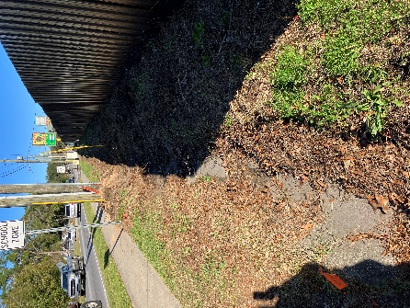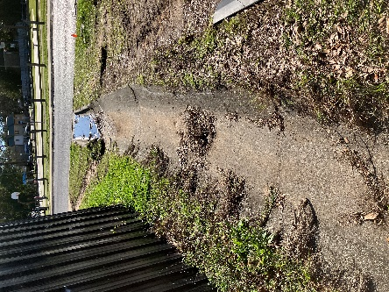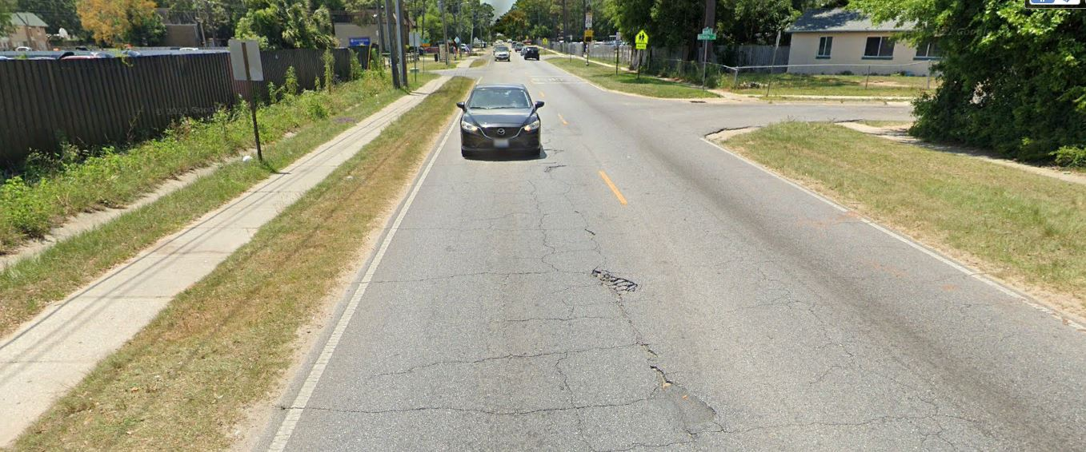
Project overview
The Massachusetts Avenue Drainage and Sidewalk Project is part of the County’s Neighborhood Enhancement Program. This Project will add ADA-compliant sidewalks on both sides of Massachusetts Avenue from Mobile Highway to Hollywood Avenue. The sidewalks in this Project will provide connectivity from Mobile Highway to the existing sidewalk at Hollywood Avenue, providing continuous pedestrian access to Pace Boulevard. This Project also consists of milling, resurfacing, installing pavement markings and minor drainage improvements along approximately 3.6 miles of roadway from Mobile Highway to "W" Street.
- Estimated Project Milestones:
  - Design Finalized and Approved: 1/22/2021
  - Bid Package or Work Order Issued: 6/7/2023
  - Contract Accepted/Notice to Proceed: 11/2023
  - Scope of Work Started: 12/2023
  - Scope of Work Finished: 3/2025
  - Certificate of Completion/Project Approval: 4/2025

Use of Evidence
The Massachusetts Avenue Drainage and Sidewalk Project is part of the County’s Neighborhood Enhancement Program. This Project will add ADA-compliant sidewalks on both sides of Massachusetts Avenue from Mobile Highway to Hollywood Avenue. The sidewalks in this Project will provide connectivity from Mobile Highway to the existing sidewalk at Hollywood Avenue, providing continuous pedestrian access to Pace Boulevard. This Project also consists of milling, resurfacing, installing pavement markings and minor drainage improvements along approximately 3.6 miles of roadway from Mobile Highway to "W" Street.

Upon completion of this Project, there will be a safer walking environment for not only the residents, but for the students walking and riding their bikes to local area schools, neighborhood stores and churches in the Montclair Community from Pace Boulevard to "W" Street. The budget remaining after the design was completed is $448,259. The current construction estimate is $3,900,000. Therefore, the staff requests ARPA funds to cover the cost of construction, which is $3,451,741 for this Project.

Project: Delano Avenue Drainage Improvement Project
Project Number: 018
Funding amount: $2.773,608.00
Percentage Complete: 5%
Project Expenditure Category: Infrastructure/5.6 Clean Water: Stormwater
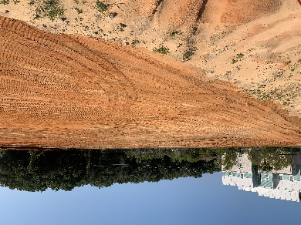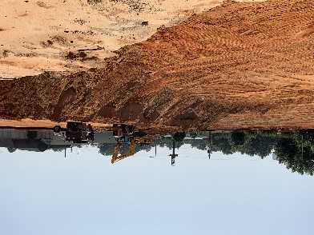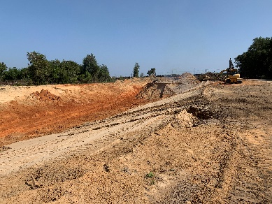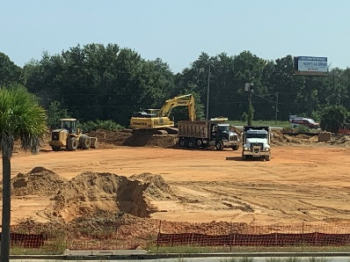

Project overview
The project consists of major drainage improvements, associated roadway improvements, and stormwater pond construction located in the following areas: west of Pace Boulevard including Herman Street, Town Street, Delano Street, Q Street; east of Pace Boulevard along the north side of Herman Street; east of Palafox Street along the north side of Herman Steet; north of Fairfield Drive and east of West Park Place; north and south of Leonard Street just west of H Street. The project will consist of major earthwork operations including the creation or modification of five (5) stormwater ponds located in these areas. Stormwater pipe will range from 18-48 inches and 2 of the 34 drainage structures will include internal weirs (smart boxes) located in FDOT right-of-way on Palafox Street and Fairfield Drive. Work will also include the demolition of a commercial buildings, demolition of a large concrete structure located in the L Street Pond, relocation of water lines, and relocation of sanitary sewer. The Contractor’s MOT plan will be subject to Escambia County approval for County roadways and FDOT approval for work at 2 locations in FDOT R/W. This project is also being funded by FEMA HMGP Grant.
- Estimated Project Milestones:
  - Construction Cost: $8,205,247.80
  - Construction Start: 8/14/2023.
  - Substantial Completion: 9/17/2024.
  - Final Completion: 10/17/2024.

Escambia County
Additional Documents

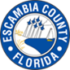
Escambia County American Rescue Plan Survey

Escambia County is seeking community input to guide its spending plan for its American Rescue Plan Act Funding. This survey is an initial step in this community engagement plan.
- What are your highest priorities for Escambia County to invest in with ARP funds? Please select 1 – 3 responses.
  - Support public health expenditure, by, for example, funding COVID-19 mitigation efforts, medical expenses, behavioral healthcare and certain public health and safety staff.
  - Address negative economic impacts caused by the public health emergency, including economic harms to our community.
  - Replace lost public sector revenue, using this funding to provide government services to the extent that were reduced due to the pandemic.
  - Provide premium pay for essential workers, offering additional support to those who have and will bear the greatest health risk because of their service in critical infrastructure sectors.
  - Invest in water, sewer, and broadband infrastructure, making necessary investments to improve access to clean drinking water, support vital wastewater and stormwater infrastructure, and to expand access to broadband internet.
- Please provide your street address. *Must be an Escambia County resident*
___________________________________________________________________
Please provide your demographic Information (Optional).

- Race/Ethnicity
- Asian/Pacific Islander
- Black/African American
- Hispanic/Latino/Latinx
- Native American/American Indian
- White/Caucasian
- Other
- Age
  - 18 – 29
  - 30 – 39
  - 40 – 49
  - 50 – 59
  - 60 – 69
  - 70 – 79
  - 80 – 89
  - 90 – Plus
- Gender
  - Male
  - Female
  - Non-binary
  - Prefer not to say
  - Other
- Income Range
  - Less than $20,000
  - $20,000 to $34,999
  - $35,000 to $49,999
  - $50,000 to $74,999
  - $75,000 to $99,999
  - Over $100,000


Encuesta del Plan de Rescate Americano del Condado de Escambia

El Condado de Escambia está buscando la opinión de la comunidad para guiar su plan de gastos para su Financiamiento de la Ley del Plan De Rescate Americano. Esta encuesta es un paso inicial en este plan de participación comunitaria.
- ¿Cuáles cree usted que son las prioridades más altas en que el Condado de Escambia debe invertir los fondos de ARP? Seleccione de 1 a 3 respuestas.
  - Apoyar el gasto en salud pública, por ejemplo, financiando los esfuerzos de mitigación de COVID-19, los gastos médicos, la atención médica conductual y cierto personal de salud pública y seguridad.
  - Abordar los impactos económicos negativos causados por la emergencia de salud pública, incluidos los daños económicos a nuestra comunidad.
  - Reemplazar los ingresos perdidos del sector público, utilizando estos fondos para proporcionar servicios gubernamentales según se redujeron debido a la pandemia.
  - Proporcionar un pago de prima para los trabajadores esenciales, ofreciendo apoyo adicional a aquellos que tienen que correr el mayor riesgo con su salud debido a su servicio en sectores de infraestructura crítica.
  - Invertir en infraestructura de agua, alcantarillado y banda ancha, realizando las inversiones necesarias para mejorar el acceso al agua potable limpia, apoyar la infraestructura vital de aguas residuales y pluviales, y ampliar el acceso a Internet de banda ancha.
- Por favor, proporcione su dirección. *Debe ser residente del Condado de Escambia*
___________________________________________________________________
Por favor, proporcione su información demográfica (opcional).
- Raza/Etnia
- Asiático/isleño del Pacífico
- Negro/Afroamericano
- Hispano/Latino/Latinx
- Nativo Americano/Indio Americano
- Blanco/caucásico
- Otro
- Edad
  - 18 – 29
  - 30 – 39
  - 40 – 49
  - 50 – 59
  - 60 – 69
  - 70 – 79
  - 80 – 89
  - 90 – Más
- Género
  - Masculino
  - Hembra
  - No binario
  - Prefiere no decir
  - Otro
- Rango de ingresos
  - Menos de $20,000
  - $20,000 a $34,999
  - $35,000 a $49,999
  - $50,000 a $74,999
  - $75,000 a $99,999
  - Más de $100,000
¡Gracias!
Condado de Escambia

